Please read the following instructions completely before starting!

Part 1: Today we are going to look at some games in Scratch. You will find games in Scratch by clicking on the ‘Scratch’ at the top left of your screen, then ‘Explore’ in the top middle of your screen. After you have clicked on both of these, you should see many games…please try several. Be ready to share what you like and do like about the games you tried!
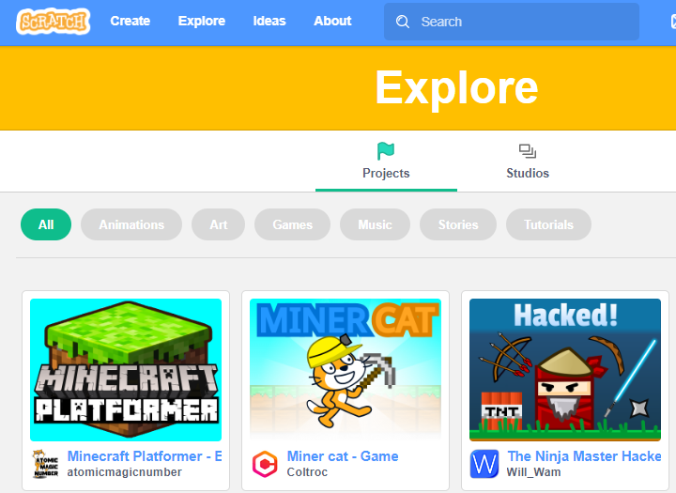

Part2: You are going to program using Scratch. You will move Scratchy, the sprite, by using Scratch, the program. Please click on ‘Create’
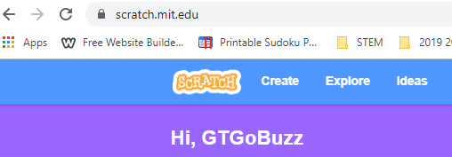
You will see this screen.
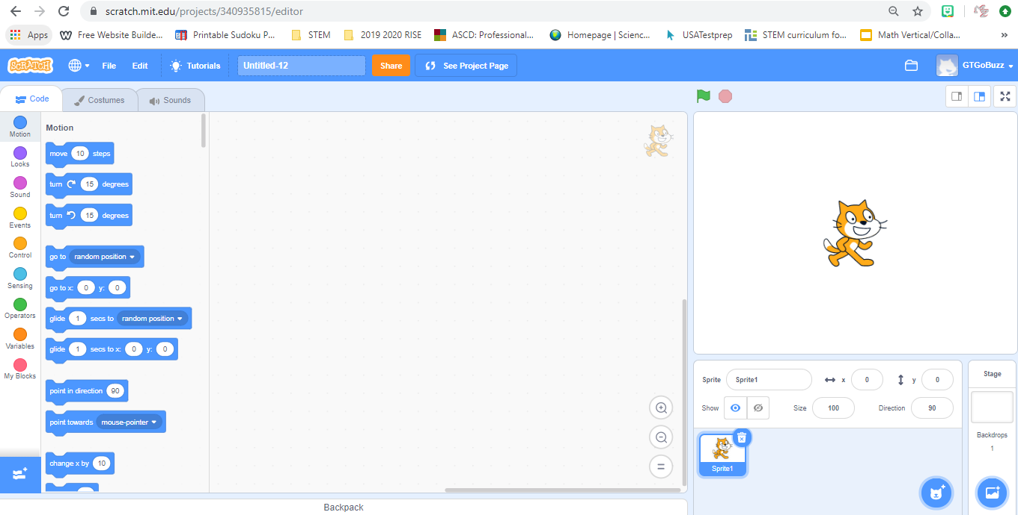
Please take time to explore the ‘Code,’ ‘Costumes,’ and ‘Sounds’ tab. I will be around to see what you have learned about program and/or changing Scratch!

Part3: Today we are also going to learn vocabulary related to a game in Scratch.

Space: Where does the game take place?
Goal: How do you win?
Components: What are all the ‘pieces’ necessary to play?
Core Mechanics: What actions are you constantly repeating?
Rules: What can or can’t you do in the game? What are the boundaries?
Can you brainstorm with your group on a game you all know and define each one of these for that game? You will turn this in. Include all team members on the paper, the game name (so I know), and the answer to each of the vocabulary related to the game you are discussing.
Enjoy the Scratch games!

