Please read the following instructions completely before starting!

PLEASE do not sign up for Scratch until I have shared a link so you can be added to my class. I will not be helping, looking at, or grading any work not submitted in the online classroom.

Today you are going to watch 3 videos and take notes on each video. These notes will be turned in. You must find 3 – 5 new things in each video. You will find the videos on the course website. They are:

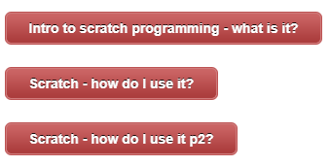
After everyone at you table is done with their notes and have turned the notes in. I will share a link with one person at each table which will allow you to join my classroom in Scratch. It is that one person’s responsibility to share with the other members at their table.

When you receive the email, you can forward my email to the other members at your table by typing their name into the ‘To’ location on the email. Make sure you include everyone at your table, before forwarding! Ask if you need help!
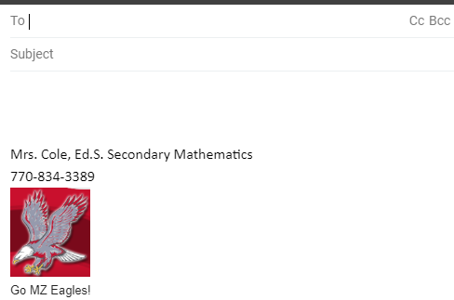
Start typing each student’s name here!
You are going to love Scratch programming!

