Please read the following instructions completely before starting!

Please view the follow 3 Prezis:
https://prezi.com/n8koa54b1uct/2019-20-middle-school-presentation/
https://prezi.com/r3pkf4euy2iw/middle-school-survival-guide/
https://prezi.com/dha_504tlqpq/my-middle-school-life/

Please view the following 2 Prezis I created for different events:
https://prezi.com/nyabrq8wueeh/copy-of-welcome-to/
https://prezi.com/ggugp07u6izc/ap-calculus/

You will learn how to create a Prezi! Please view how to create a Prezi at the link https://www.youtube.com/watch?v=ccaI7J8ohr8

Before you can start on your Prezi, you have to sign up for an account. Go to www.prezi.com, then click “get started”
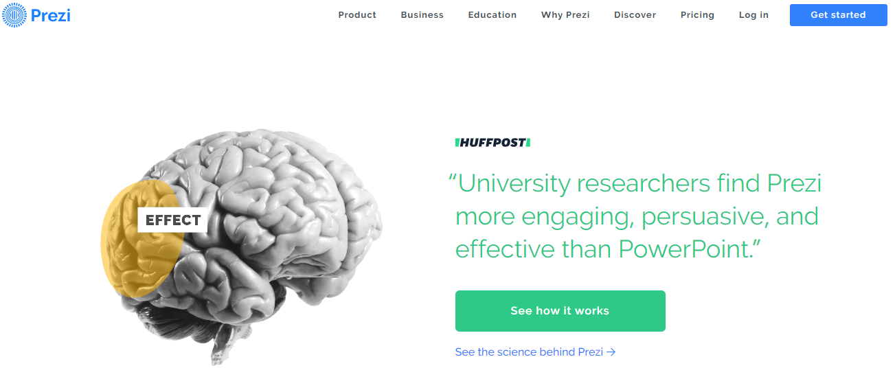

Click “log in”
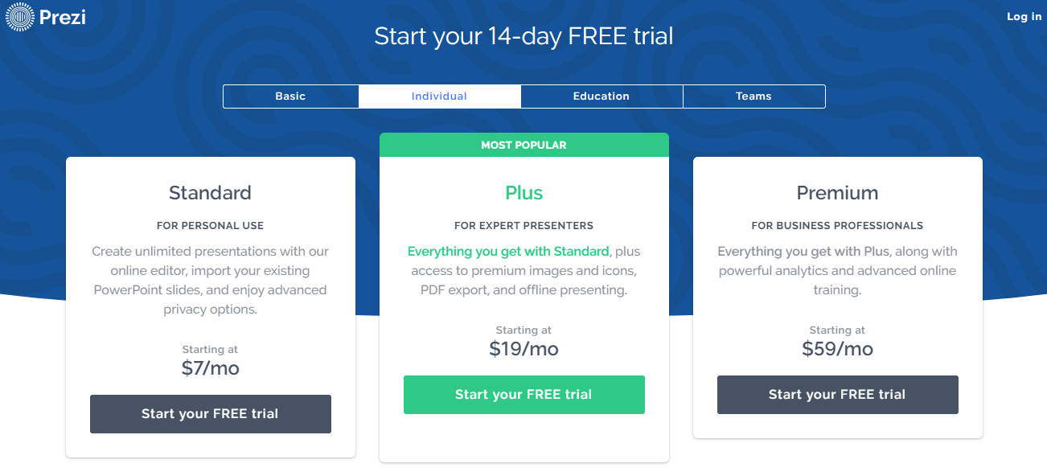

Click “Sign up”
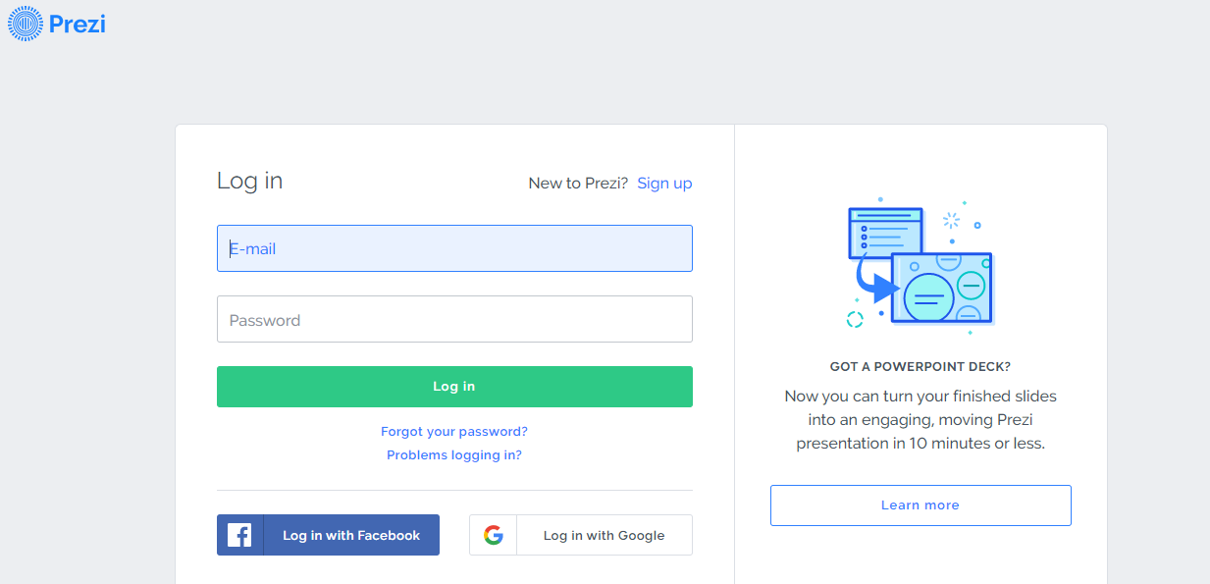

Click “basic” and click “continue”
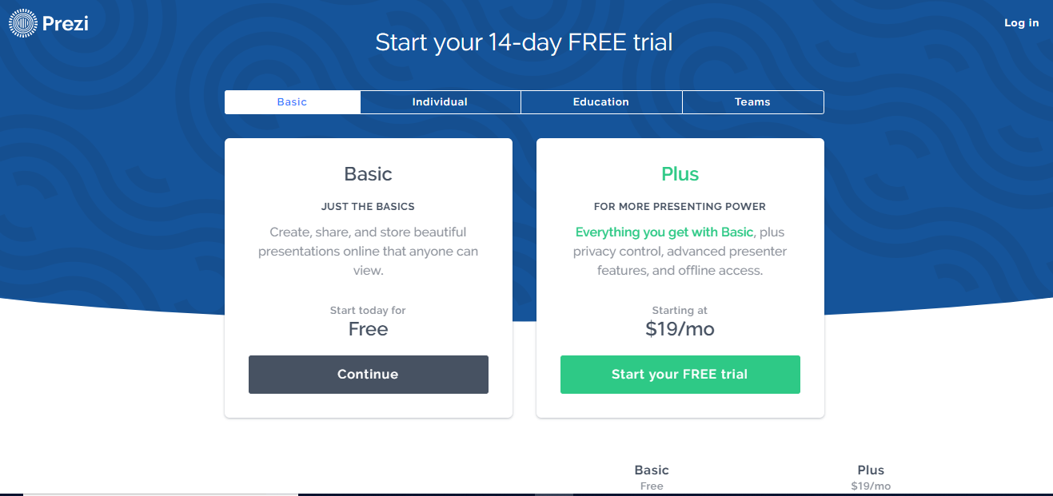

Fill out the information for the ‘free basic account’ in order to begin using Prezi.
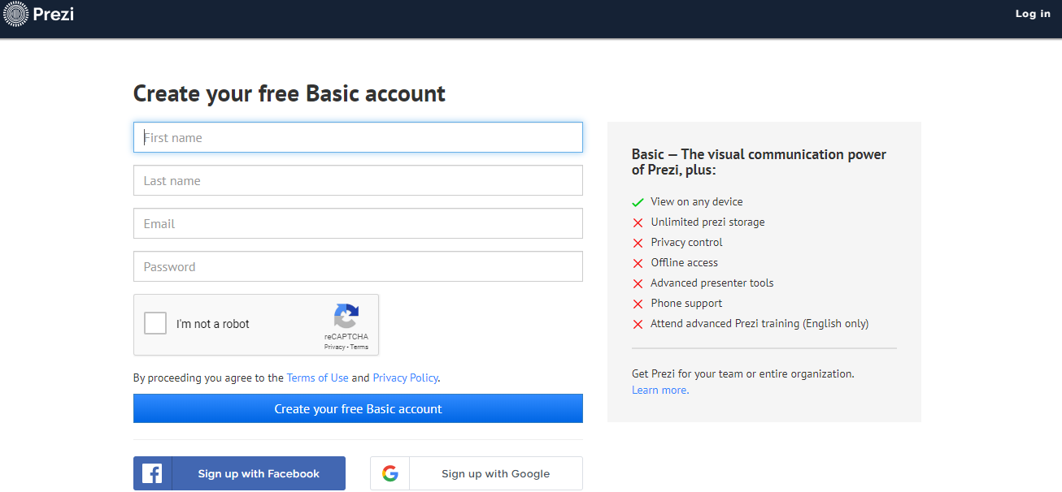

Your Prezi can be the topic of: about you, the history of Mt. Zion or Carroll County, businesses on the Carrollton City square, sports, or another topic of your choice (but I must approve it, so please speak to me).
Your Prezi will have a minimum path of 20. The Prezi will incorporate a minimum of 5 images. The Prezi will have a minimum of 4 videos. You will use a lot of text/writing in your Prezi. Please make sure your typing/spelling errors are minimum!
You will have several days to create your Prezi. You will be asked to share your Prezi link with me at some point before the final product is turned in. This checkpoint will be a grade! Your final Prezi will also be a grade.
After your Prezi is complete, you will be asked to share your Prezi with one other person, so they can give you feedback on your work.
Remember you will not post pictures of yourself in your Prezi because this will be on the internet.

When you have completed your Prezi, please answer the following questions on your own paper.
1) What was your Prezi topic?
2) How difficult was designing and building your Prezi?
3) Did your Prezi turn out as good as you wanted it to? Why or why not?
4) What is one thing you would change if you design a Prezi about another topic? Please explain.
5) If you were a business owner, would you use Prezi to advertise for your company? Please explain.
6) Beside advertising for a company, where could you see a use for Prezi?

Have fun building your Prezi!!

