August 7, 2019 Wednesday

1) Find your seat
2) On the index card, write you first and last name on the top red line and write a response in complete sentences to the following question:
What do you plan to improve on this school year?

August 8, 2019 Thursday

1) Find your seat
2) Write a response in complete sentences to the following question:
List your classes in order from most liked to least liked? Write a minimum of 2 sentences stating why your first class listed is your favorite class and the last class listed is your least favorite class.
August 9, 2019 Friday
Whew…it’s Friday!
Please get your ‘eyeopener’ sheets!
On a scale of 1-10 (1 being the most fearful and 10 being not afraid at all) state the number that indicates how comfortable you are speaking in front of your classmate. Explain why you chose this number.

August 12, 2019 Monday
Have you ever used a ruler? What were you measuring?
Have you seen someone use a ruler? What were they measuring?

August 13, 2019 Tuesday
Please add and subtract the following fractions:
1/2 + 1/4 3/8 + 1/4
1/2 – 1/4 3/8 – 1/4
…and the tallest structure was……55”, 51”, 47”, 44”, 40.5”, 23”

August 14, 2019 Wednesday
Do you have a favorite card or board game you like to play?

Who do you play this game with?

August 15, 2019 Thursday

What is something interesting you have learned related to science, this year or a previous year?

August 16, 2019 Friday
What is something interesting you have learned related to math, this year or a previous year?

August 19, 2019 Monday
What are your 5 most used apps on your phone?

August 20, 2019 Tuesday
What are characteristics of a good webpage?

August 21, 2019 Wednesday
On a scale of one to ten how good are you with technology (1 = no one asks me because I don’t know…10 = I am the tech expert)

August 22, 2019 Thursday
Is developing your own website interesting to you, or not so much? Explain why?

August 23, 2019 Friday
There are other tools to develop websites besides Weebly? Can you find some?

August 12, 2019 Monday

August 13, 2019 Tuesday

August 14, 2019 Wednesday

August 15, 2019 Thursday

August 16, 2019 Friday

August 12, 2019 Monday

August 13, 2019 Tuesday

August 14, 2019 Wednesday

August 15, 2019 Thursday
August 16, 2019 Friday
September 30, 2019 – Last day of September!

Get out a sheet of paper – you will use this all week!
What is your grade in STEM?
Are you missing any assignments? If so, which ones?

October 1, 2019 – Tuesday!
Get the same sheet of paper from yesterday (it is in the black bin)– you will use this all week!

Outside of this class, where might you be able to use a Prezi?
What is your Prezi topic?
Approximately how far are you on the Prezi – what is your percent? (10% just getting started, 30% good progress yesterday, should be finished by the end of the week)
If necessary (this does not apply to all, only student with <70%) what are you doing to improve your grade in this class?

October 2, 2019 – Wednesday!
Get the same sheet of paper from yesterday (it is in the black bin)– you will use this all week!

How many paths have you completed on Prezi?

How many images have you uploaded? How many videos?

Today you will share you url with me within the first 10 minutes of class.

October 3, 2019 – Thursday
How far are you on the Prezi (100% = ready to present today, 50% = will probably be ready tomorrow)?
Have you ever visited a manufacturing facility? If so, where?

October 5, 2019 – Fri-yay!
Do you have any robotics experience?
Review the following links Intro to Edison Robots & Intro to EdBlock
on the class website. Write down two things you learned from each video! Please use complete sentences with proper punctuation!
Thank you!

October 14, 2019 – Monday!
State 5 things you did over your break. AFTER you write this, discuss your break with people at your table.
Before you turn in your eyeopener….
Access the website under the STEM Adventures,
Review the 2109 Fall Mercedes Benz Stadium….
On the bottom right of today’s work indicate yes or no if you are interested in attending (probably in December), this will cost you/your parent $15, we will have a bag lunch/bring your own

October 15, 2019 – Tuesday!
What is a barcode? Where do you see barcodes? Please list a min of 3 examples? What information is stored in barcodes?

October 16, 2019 – Wednesday!
What are sensors? What do sensors detect? Where are some places you notice sensors?

October 17, 2019 – Thursday!
What is an obstacle? What are choices you have when you encounter an obstacle?

October 18, 2019 – Friday!
Continue on finishing your questions…please ask yourself should 12 questions have taken me 3+ hours to complete? Why is this taking me so long?!?
IF YOUR QUESTIONS ARE DONE, THANK YOU!!! Finish/start on 11.1 and start and finish 11.2. Your groups questions should be submitted via email. SEE ME if you do not know how to use CTRL+C and CTRL+V!
Have fun with the Edison robot!!
Today you have 15 minutes to design a maze. You have 5 minutes to test your maze. After 20 minutes, your team will present your obstacle avoidance maze. (Write these on your eyeopener) Maze Requirements: a min of 5 obstacles, 1 left and 1 right turn avoidance, minimum of 10 seconds in the maze before escape

October 21, 2019 – Monday!
How could lights be used in robotics?

October 22, 2019 – Tuesday!
What are some ideas you have that the Edison can do or can’t do?

October 23, 2019 – Wednesday!
What application do you see a technology were something follows a line? (from yesterday)

October 24, 2019 – Thursday!
What application do you see a technology were something stays inside a line? (from yesterday)

October 25, 2019 – Friday!
Can you think of an application where you would want to control a robot/item with a remote control?

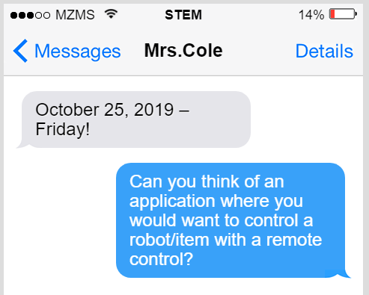

October 28, 2019 – Monday!
E.Q. I can successfully use Scratch programming! I can successfully Grow A Game!!

Eye-opener: How important is vocabulary? Why?

P & D
Can you describe 3 vocabulary words to a friend?
Can you write 3 vocabulary words in a short paragraph and share with a friend?

Let’s summarize: What new vocabulary words are most challenging?
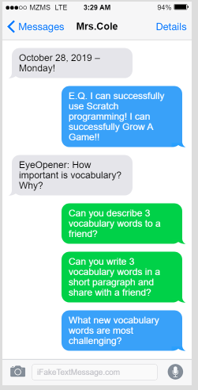

October 29, 2019 – Tuesday!
E.Q. I can successfully use Scratch programming! I can successfully Grow A Game!!
Eye-opener: Can you name any computer programming languages?
Please list…use tech, if necessary.
P & D
Discuss with a neighbor how scratch works for 2 minutes.
Write a short code which perform at least 4 commands.

Let’s summarize: What can we do with our new programming language?

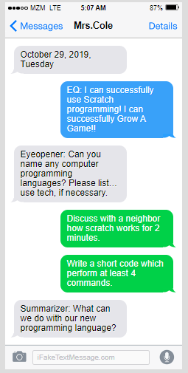

October 30, 2019 – Wednesday!
E.Q. I can successfully use Scratch programming! I can successfully Grow A Game!!
Eye-opener: What is a programming language? What is a programming language used for?
P & D
One person at a table share – what is scratch?
All people at table write what scratch is adding at least 2 more facts.
Let’s summarize: What is a short 3-5 box program you could write? Use the symbols, share with your table.

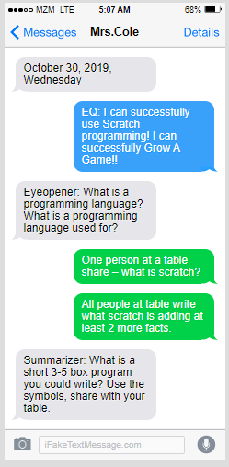
October Boo, 2019 – Thursday!
E.Q. I can successfully use Scratch programming! I can successfully Grow A Game!!
Eye-opener: You may need technology for this one…
What companies hire computer programmers?
What is the average salary of a computer programmer?
What is one more interesting fact about cp?
P & D
With a neighbor use game vocabulary in a quick discussion, you use 3 word, they use 2.
Find a game you both know and use game voc to identify the parts of the game.
Let’s summarize: What makes computer games fun? What doesn’t?
Id a common game & use the game vocabulary.
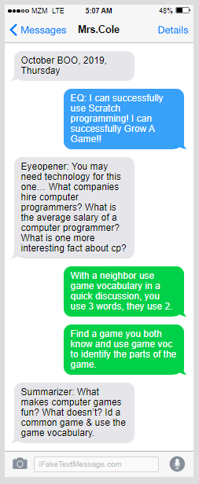
November 1, 2019 – Friday!
E.Q. I can successfully use Scratch programming! I can successfully Grow A Game!!
Eye-opener: What makes a game interesting…?
List several things (min = 5
P & D
What parts do you need to successfully grow a game?
What was the most difficult component of growing a game? Why?

Let’s summarize:
Share your grow a game on flipgrid. Comment on someone’s who is not at your table and not commented on

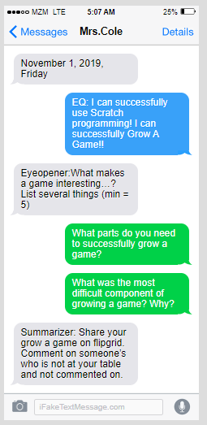
November 4, 2019 – Monday!
I can design a computer game using code. I can design a computer game using code with the focus on CHANGE!
What are some things which ‘damage’ our earth? Minimum of 3.
How can I/we help?
Can you share three things you know about G4C?
Discuss your topic and why you are interested in designing a video game about your topic?

Share one thing you are going to do to improve your work. Share one thing you think your neighbor should do to improve their work.
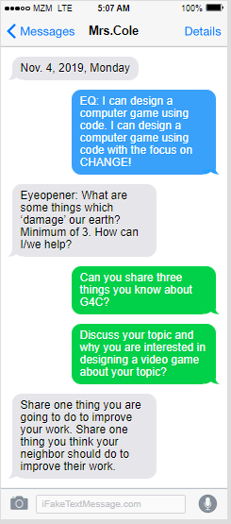

November 5, 2019 – Tuesday!
I can design a computer game using code. I can design a computer game using code with the focus on CHANGE!
Do you have a special bond with an animal? How is that bond special?
Review your design for completeness.
Review someone’s creation at another table for completeness & offer feedback.

Take 2 minutes in teams of 2 to show your design and your game vocabulary to someone who is not at your table.
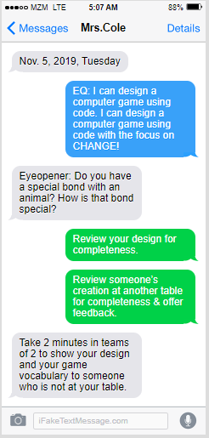
November 6, 2019 – Wednesday!
I can design a computer game using code. I can design a computer game using code with the focus on CHANGE!
What is a disability? Minimum of 3.
What can be changed about video games in order to make them inclusive for people with disabilities? Minimum of 3.
What questions for you have about the G4C timeline or G4C phases?
Who can answer that question?!?
Take 1 minute to introduce your emoji to team members.
Turn your emoji in to me.
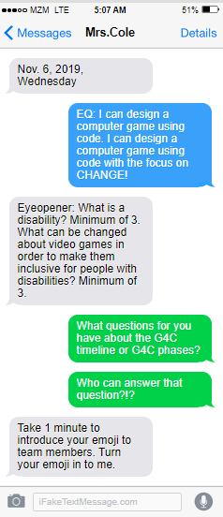

November 7, 2019 – Thursday!
I can design a computer game using code. I can design a computer game using code with the focus on CHANGE!
Who is mouse.org?
Who is thetruth.org?
Who is petspace.org?
Who is att.com?

Pick your favorite to explore – write down 3-5 facts.
What are we going to be using mouse.org for?
How does mouse.org relate to our 2 project posters from yesterday?
Share 1 fact about a company you did not research!
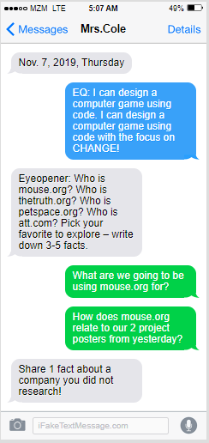
November 8, 2019 – Friday!
I can design a computer game using code. I can design a computer game using code with the focus on CHANGE!
Think of a game you know well (board or video)…what is the one biggest reason you like this game. Please explain.
Name 3 or the 5 game vocabulary.
Use 3 of the 5 game vocabulary from your Grow a Game in a paragraph.
Explain the Grow-A-Game steps for a successful game…what is different about our game?
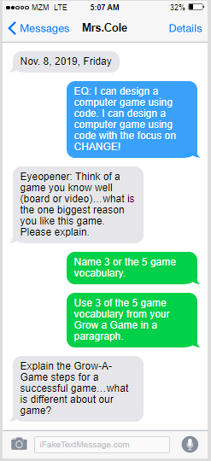

Nov. 11, 2019 – Monday!
EQ: I can learn how to design video games intro to game design, core mechanics, goals obstacles chance & objects found.
Eyeopener: What is game design? Share a game you would like to re-design & why

Is your emoji ready to move? How far along did you get?

Nov. 12 2019 – Tuesday!
E.Q. I can learn how to design video games intro to game design, core mechanics, goals obstacles chance & objects found.
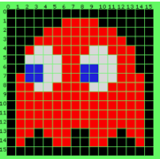
Eyeopener: What are mechanics? What are the ‘mechanics’ for a school?

Summarizer: What are core mechanics?

Proficient: What will be the core mechanics on the game you design?

Distinguished: What are core mechanics of a game everyone at your table knows? Share.

Nov. 13, 2019 – Wednesday!
E.Q. I can learn how to design video games intro to game design, core mechanics, goals obstacles chance & objects found.

Eyeopener: Think of a video game or board game you know. What is the goal, obstacles, and chance for that game?

Summarizer: Find a partner who knows a video game you know and identify the goal, obstacles, and chance for that game. Turn this in!

Proficient: What is the goal of a familiar game to you? Share this with a partner.

Distinguished: Find the most familiar game and discuss the goals, obstacles and chance in that game.

Nov. 14, 2019 – Thursday!
E.Q. I can learn how to design video games intro to game design, core mechanics, goals obstacles chance & objects found.
Eyeopener: State three new things you know about game design. Speak to a neighbor to find one more that you did not think of. There should be 4 things on your paper you turn in.

Summarizer: Share several games that have ‘found object.’ What is the object…who/what finds it?

Proficient: What is an ‘objects found game?’

Distinguished: What object will be found in your game? ...Recall the three topics!

Nov. 15, 2019 – Friday!
E.Q. I can learn how to design video games intro to game design, core mechanics, goals obstacles chance & objects found.
Eyeopener: How do you image the work setting of a Game Designer, were do they live, what do they do?
ARE YOU INTERESTED? https://www.rozzylearningcompany.com/career-kid-challenge/
Summarizer: Share something you feel you learned well in the game design phase.
Proficient: Share with a partner something you learned in game design.

Distinguished: On a paper with your group ‘add’ something you learned about game design…you may not use something someone previously used!

Nov. 18, 2019 – Monday!
E.Q. What is Scratch? How can I use Scratch to building games?
What is a Re-mix?
Eyeopener: What are the Space, Goal, Components, Core Mechanics, Rules of your G4C? Please answer in complete sentences.
ARE YOU INTERESTED? I NEED NAMES & Groups!! https://www.rozzylearningcompany.com/career-kid-challenge/
Are you ready for phase 2?
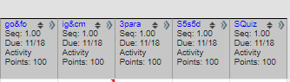
Intro to GD – Hack TTT
Core Mech – Describe 5 game components
Goals Obstacles Chance (Space invaders)
Found Object – describe with a pic
Summary 3 paragraphs 5 similarities & 5 differences Quiz GD

Summarizer: Are you still in Phase 1 or have you moved to Phase 2?

Proficient: What is Scratch?

Distinguished: How are you going to use Scratch in your G4C creation?

Nov. 19 2019 – Tuesday! – If you are working on Rozzy, please start Rozzy, everyone else = eyeopener!
E.Q. What is Scratch? How can I use Scratch to building games?
What is a Re-mix?
Eyeopener: Please look at your responses from yesterday & sketch an idea of what your Scratch game is going to look like. 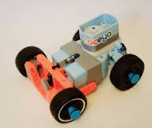

Summarizer: Find someone whose emoji is at the same progress you are at…discuss your progress: Where are you stuck? What is going good?
Proficient: What are code blocks used for?

Distinguished: Share a quick code block program with a neighbor.

Nov. 20, 2019 – Wednesday!
E.Q. What is Scratch? How can I use Scratch to building games?
What is a Re-mix?
Eyeopener: What is a re-mix? Give 3 examples.
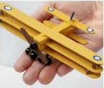
Rozzy: Please get started!

Summarizer: Turn and discuss with your partner where you are in the poster.
Proficient: How can a re-mix help you in your game design?

Distinguished: What game might you re-mix and why did you choose this game?

Nov. 21, 2019 – Thursday!
E.Q. What is Scratch? How can I use Scratch to building games?
What is a Re-mix?
Eyeopener: What might be a title of your game? What might your backdrop look like? Rozzy: Please get started!
Summarizer: Share your game title with a neighbor. Get their feedback.
Proficient: Why do game titles need careful thought?

Distinguished: Choose one of the following ‘unpopular’ video games. What does their title tell you? E.T. the extra-terrestrial, Sonic the Hedgehog, or Castlevania II

Nov. 22, 2019 – Friday! Gooble…
E.Q. What is Scratch? How can I use Scratch to building games?
What is a Re-mix?
Eyeopener: What did your complete yesterday? State 3 things you learned yesterday.
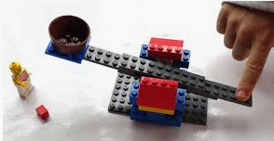 Rozzy: Please get started!
Summarizer: Talk and share 3 things that you learned in the Practice Designing Games in Scratch phase.
Proficient: How can Scratch help you design a G4C?

Distinguished: Draw 3 things you learned in the Scratch Developer Phase and describe these to a neighbor.

Dec. 2, 2019 – Monday!
E.Q. How are you using Scratch to re-mix games?
Eyeopener: Log in to mouse.org and share your progress with one person at your table, also write your response on the eyeopener paper

Rozzy: Please get started! When is your due date? What is due? – know these answers I am coming around to check!
Summarizer: Check your emoji and your progress…share something your learned today!
Proficient: What is a scratch developer?
Distinguished: What is a scratch activist?

Dec. 3, 2019 – Tuesday!
E.Q. How are you using Scratch to re-mix games?
Eyeopener: Log in to mouse and write down the activity and step you are currently working on.
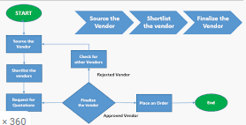
Rozzy: Please get started! The building needs to wrap up! The documentation (paragraph, powerpoint, and pictures) needs to start! Everyone has a part in pulling this together.

Summarizer: Check your emoji and your progress…
Proficient: What a video games for?

Distinguished: What are ‘games for change’ G4C for?

Dec. 4, 2019 – Wednesday!
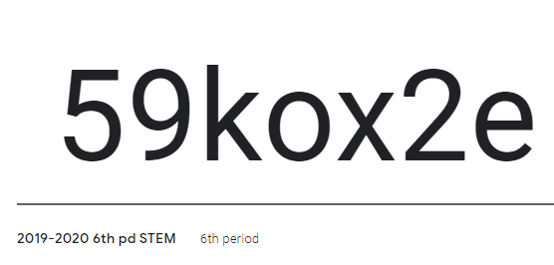
E.Q. How are you using Scratch to r e-mix games?
Eyeopener: Send a screen capture of your scratch work to lyn.johnsoncole@carrollcountyschools.com
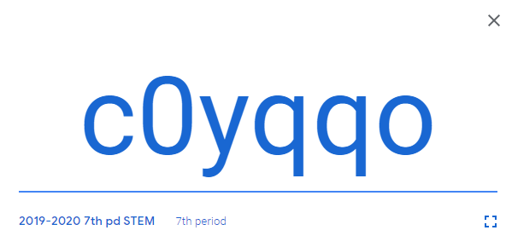
Write your school email address on your eyeopener paper. Also, please join my GoogleClassroom (the code is on the left!). 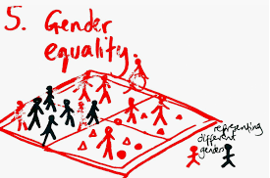
Rozzy: Please get started! The building needs to wrap up! The documentation (paragraph, powerpoint, and pictures) needs to start! Everyone has a part in pulling this together.
Summarizer: Check your emoji and your progress…
Proficient: What are the topics of the G4C challenge?
Distinguished: How should the G4C challenge be judged?

Dec. 5, 2019 – Thursday!
E.Q. How are you using Scratch to re-mix games?
Eyeopener: How has the scratch game design process impacted the way you look at video games? If you haven’t…please sign up for GoogleClassroom with the code below!

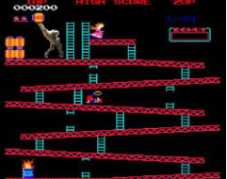
Summarizer: Check your emoji and your progress…
Proficient: What did we use in Grow-A-Game?
Distinguished: How did you Grow-A-Game in scratch?

Dec. 6, 2019 – Friday!
E.Q. How are you using Scratch to re-mix games?
Eyeopener: Would you consider a game developer/programmer as a potential career? Why or why not?
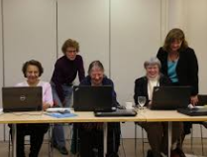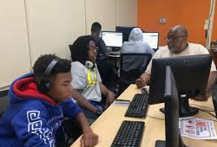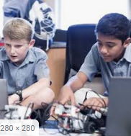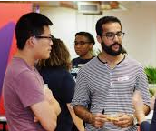
Summarizer: Check your emoji and your progress…
Proficient: What is a job?
Distinguished: How is a job different than a career?
December 9, 2019 – Monday!
9 more days until Christmas break!
E.Q. How can G4C impact society? Is this a waste of time…or a good use of time? Why?
Eyeopener: Log in to mouse.org and share your progress with one person at your table, also write your response on the eye-opener paper
Summarizer: Share at your table something you like about mouse/scratch, Write 1 idea per person on paper and hand to me!
Proficient: Look at your emoji…are you making adequate progress through mouse.org and the G4C challenge in order to submit by the due date?

Distinguished: If you wanted to move faster through mouse.org what are some things you might consider…share at your table.

Dec. 10, 2019 – Tuesday!
8 more days until Christmas break!
E.Q. How can G4C impact society? Is this a waste of time…or a good use of time? Why?
Eyeopener: State something your find easy about mouse.org and something you find difficult about mouse.org. If you could change one thing about mouse.org, what would it be?
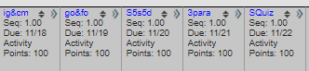
16.0+16.1 16.2+16.3 16.4 P1 16.4 P2 16.4 P3
2 2
Now…lets talk about grades!

Summarizer: Check your emoji and your progress…share something your learned today!
Proficient: Do you like online learning?
Distinguished: How is online learning different/similar than traditional learning?

Dec. 11, 2019 – Wednesday!
7 more days until Christmas break!
E.Q. How can G4C impact society? Is this a waste of time…or a good use of time? Why?
Eyeopener: What do you think the categories were for the following 2018 G4C winners? Once we guess the categories, we are going to play the games!

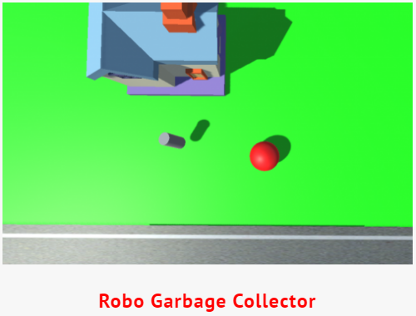
https://brunswik.github.io/robogarbagecollector/
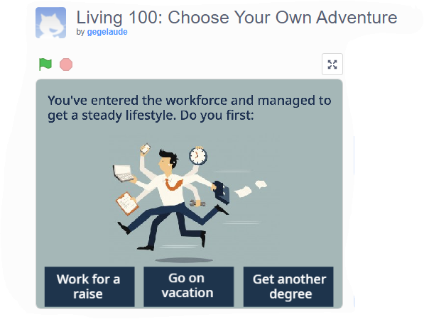
https://scratch.mit.edu/projects/294584948/

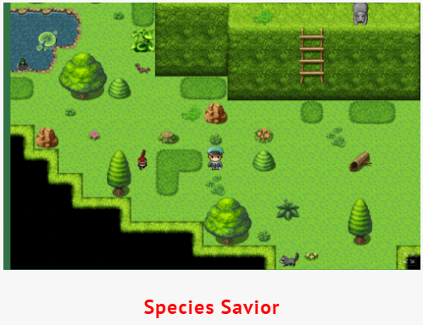

Link broke : ‘ (

16.0+16.1 16.2+16.3 16.4 P1 16.4 P2 16.4 P3
2 2

Summarizer: What are the three categories for this year’s G4C? In just a minute…A show of hands for who is interested in each category!
Proficient: What are the 3 G4C categories this year?

Distinguished: If you could create an impact game topic, what would the category be?

Dec. 12, 2019 – Thursday!
6 more days until Christmas break!
E.Q. How can G4C impact society? Is this a waste of time…or a good use of time? Why?
Eyeopener: Please use your laptop to research: How many people in the US are video gamers? How much money is spent on video games yearly? How many new games are released daily? Find one other fact!

Summarizer: Discuss with your table partners…do you see yourself as a game designer? Why or why not? ….be ready to share!
Proficient: What are characteristics of a video gamer?

Distinguished: How are a video gamer and a video game designer similar and different?

Dec. 13, 2019 – Friday!
5 more days until Christmas break!
E.Q. How can G4C impact society? Is this a waste of time…or a good use of time? Why?
Eyeopener: Who is one person outside of class you are going to share your scratch game with? Why?
Summarizer: Write the answer to: How can G4C impact society? Is this a waste of time…or a good use of time? Why? Please turn in! Thank you
Proficient: What is the purpose of impact games?

Distinguished: Are any of your ‘current’ favorite video games an impact game? How do you know.

December 16, 2019 – Monday!
4 more days until Christmas break!
E.Q. How can G4C impact society? Is this a waste of time…or a good use of time? Why?
Eyeopener: Think of a video game you play at home….state the objective of the game using your video game vocabulary?
Summarizer: Share at your table something you like about mouse/scratch, Write 1 idea per person on paper and hand to me!
Proficient: If you were a video game designer what would be the goal of a game you designed?

Distinguished: How could you change your game and make it a G4C?

Dec. 17, 2019 – Tuesday!
3 more days until Christmas break!
E.Q. How can G4C impact society? Is this a waste of time…or a good use of time? Why?
Eyeopener: Based on your video game from yesterday, what are the predominate colors used by the game designer? Do you believe this is intentional or unintentional?
Summarizer: Check your emoji and your progress…share something your learned today!
Proficient: What colors would you use in a video games and why?

Distinguished: How could you market your game to a person who is color blind or has difficulty seeing?

Dec. 16, 2019 – Wednesday!
2 more days until Christmas break!
E.Q. How can G4C impact society? Is this a waste of time…or a good use of time? Why?
Eyeopener: If you could change three things about your games from M & T what would they be and why?
Summarizer: What are the three categories for this year’s G4C? In just a minute…A show of hands for who is interested in each category!
Proficient: What is a video game you know and a flaw that you would fix?

Distinguished: Discuss with a neighbor a game you both know and something that would make it a better game!

Dec. 17, 2019 – Thursday!
1 more days until Christmas break!
E.Q. How can G4C impact society? Is this a waste of time…or a good use of time? Why?

Eyeopener: What would a Christmas game look like in Scratch?
Draw it first then share your idea with one person at your table.
Summarizer: Discuss with your table partners…do you see yourself as a game designer? Why or why not? ….be ready to share! (Use hands)
Proficient: Share with a partner what your video games from Scratch would look like from the beginning of class.

Distinguished: Offer one suggestion for improvement on each other’s games.

Dec. 18, 2019 – Friday!
NoHoHoHo… more days until Christmas break!
E.Q. How can G4C impact society? Is this a waste of time…or a good use of time? Why?
Eyeopener: What would a Christmas game look like in Scratch?
Describe it to me…on your paper!
Summarizer: Write the answer to: How can G4C impact society? Is this a waste of time…or a good use of time? Why? Please turn in! Thank you
Proficient: If you were a video game designer what type of people would you design your game for?

Distinguished: What is one thing you could change that would make your game interesting to more than your target audience?

Jan. 6, 2020 – Monday!
E.Q. How can G4C impact society? Is this a waste of time…or a good use of time? Why?
Eyeopener: Welcome back! Discuss in a minimum of 4 sentences something you did over the break which required creativity.

Summarizer: What skills did your team need to be successful in the pyramid build?
Proficient/Distinguished:
What makes a good team?
Discuss success you have had in a team – what made this team successful?

Jan. 7, 2o2o – Tuesday!
E.Q. How can G4C impact society? Is this a waste of time…or a good use of time? Why?
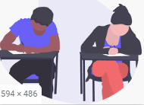
Eyeopener: Did you play any video games over the break? Which did you play most?
What is the best and worst feature of this game?

Summarizer: Turn to a neighbor and discuss a video game you both know. Discuss what you like and dislike about the video game.
Proficient/Distinguished:
What makes a video game successful?
What makes a consumer buy a video game?

Jan. 8, 2020 – Wednesday!
E.Q. How can G4C impact society? Is this a waste of time…or a good use of time? Why?
Eyeopener: What is mouse create used for?
What is scratch used for?

Summarizer: How do mouse and scratch work together in G4C?
Proficient/Distinguished: Would you rather give written or verbal feedback? Why?
Would you rather receive written or verbal feedback? Why?

Jan. 9, 2020 – Thursday!
E.Q. How can G4C impact society? Is this a waste of time…or a good use of time? Why?

Eyeopener: What is an emoji? If you had your own personal emoji, what would it look like? Please draw your emoji.

Summarizer: What is emoji short for? Emoticons
When was the first emoji create? 1999
What was the first emoji?

Proficient/Distinguished: Draw an emoji for a person at your table who is seated on the right.
Draw an emoji which represents your whole table.
Share both!

Jan. 10, 2020 – Fri-yay!

E.Q. How can G4C impact society? Is this a waste of time…or a good use of time? Why?

Eyeopener: What is netiquette?
https://svslibrary.region-12.org/digitalcitizenship/email
watch both videos on the left. List 5 things that you learned!

vs

Summarizer: Write an email to a friend stating how your day went. Be aware of your netiquette!

Proficient/Distinguished: Deliver your email to a friend who is not at your table to correct using netiquette rules.
Return the email to the original sender for review.
Jan. 13, 2020 – Monday!
E.Q. How can G4C impact society? Is this a waste of time…or a good use of time? Why?
Eyeopener: Write an email to a family member asking for a favor. ‘Think netiquette….’
Summarizer: Why should society use video games to influence change?
Proficient/Distinguished: Can video games influence the way people think?
Provide an example of how video games influence the way people think.

Jan. 14, 2019 – Tuesday!
E.Q. How can G4C impact society? Is this a waste of time…or a good use of time? Why?
Eyeopener: Get you ‘email’ from yesterday & have a seat!
Switch ‘emails’ with someone close! Offer them feedback on their ‘email!’

Summarizer: How important is netiquette techniques in your online communications? Why?
Proficient/Distinguished: Write a sentence that you might text to a friend.
Switch! Correct this sentence like you might write it to your teacher/principal.

Jan. 15, 2019 – Wednesday!
E.Q. How can G4C impact society? Is this a waste of time…or a good use of time? Why?
Eyeopener: When Ashley was 15, her mother was 37. Now, her mother is twice her age. How old is Ashley?

Ashley is 22. Her mother is 22 years older, so when Ashley is 22, she’s now half her mother’s age.
Summarizer: Turn to a neighbor and tell them something you learned today.
Proficient/Distinguished: Discuss, as a table, something you learned today.
Shortly, you will be sharing with the group!

Jan. 16, 2019 – Thursday!
E.Q. How can G4C impact society? Is this a waste of time…or a good use of time? Why?

Eyeopener: If:

2 + 2 = 44

3 + 3 = 96

4 + 4 = 168

5 + 5 = 2510
Then:
6 + 6 = ? 3612

Summarizer: Emoji check! Do you need to move your emoji?
Proficient/Distinguished: Find someone whose emoji is at the same place as your emoji!
Discuss what you are working on with this person.

Jan. 17, 2019 – Friday!
E.Q. How can G4C impact society? Is this a waste of time…or a good use of time? Why?
Eyeopener:
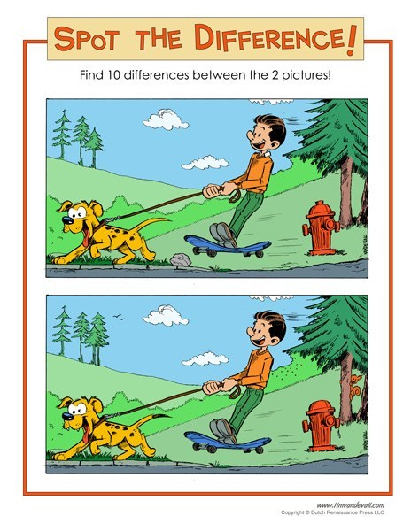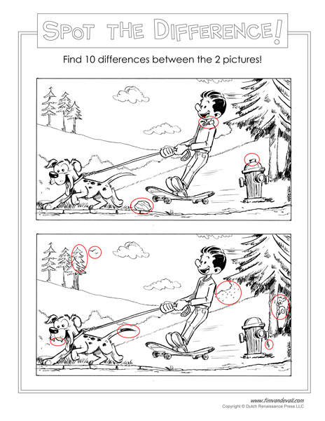
Summarizer: If you could change one school rule, what would it be?
Proficient/Distinguished: Discuss/share your school’s rules suggestions with your table.
Would learning still take place? Would your new school be safe?
Jan. 20, 2020 – Monday!
E.Q. How can G4C impact society? Is this a waste of time…or a good use of time? Why?
Eyeopener: HOLIDAY
Summarizer:
Proficient/Distinguished:
Jan. 21, 2020 – Tuesday!
E.Q. How can G4C impact society? Is this a waste of time…or a good use of time? Why?
Eyeopener: Create an email stating what you did with your extra day off, which you are going to share with a friend! To: “your friend”

Summarizer: Me: read new messages
Vote: good/bad
Proficient/Distinguished: Why does it matter how an email sounds?
What are some good words to use in an email?
Turn them in: whoever’s last name has the most letters.

Jan. 22, 2020 – Wednesday!

E.Q. How can G4C impact society? Is this a waste of time…or a good use of time? Why?
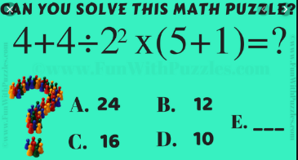
Eyeopener:

Summarizer:

Proficient/Distinguished: Unscramble: Eewylb You make one…

Turn them in: whoever was born furthest from MZ.

Jan. 23, 2020 – Thursday!
E.Q. How can G4C impact society? Is this a waste of time…or a good use of time? Why?
Eyeopener:
Summarizer:

Proficient/Distinguished: Unscramble: Nzit omonu You make a compound word scramble.

Turn them in: whoever has traveled the furthest from GA.

Jan. 24, 2020 – Friday!
E.Q. How can G4C impact society? Is this a waste of time…or a good use of time? Why?
Eyeopener: What is the pattern…write the next two rows.
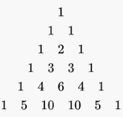
Summarizer: Make a word scrabble and share it with the person on your left.
Proficient/Distinguished: What is the pattern? 0,1,1,2,3,5,8,13 You make a pattern using numbers.

Turn them in: whoever’s parent was born furthest from MZ.

Jan. 27, 2020 – Monday!

E.Q. How can G4C impact society? Is this a waste of time…or a good use of time? Why?
Eyeopener: Do you see the pattern?
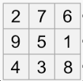

Summarizer: Turn to a neighbor & share something you made progress on! Be sure to listen to their progress too.
Proficient/Distinguished: Make one suggestion that your neighbor could do.
Review suggestions with everyone at your table.
Take up the papers: who has the most pets

Jan. 28, 2020 – Tuesday!
E.Q. How can G4C impact society? Is this a waste of time…or a good use of time? Why?
Eyeopener: 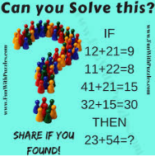
Summarizer: Create a number puzzle with a partner….turn it in!
Proficient/Distinguished: Can you solve one/or more?
Please share your strategy and answer.
Take up the papers: rock, paper & scissor winner

Jan. 29, 2020 – Wednesday!
E.Q. How can G4C impact society? Is this a waste of time…or a good use of time? Why?
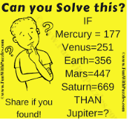
Eyeopener:

& Keith’s game review…per table….one side of the index card = things you like, the other side of the index card = things you would like to see improved

Summarizer: Why are video games a ‘good’ choice for changes in society?
Proficient/Distinguished: What video game exists today that might ‘change’ society?
What is a popular video game and what small changes could be done to impact society?
Take up the papers: rock, paper & scissor winner
Jan. 30, 2020 – Thursday!
E.Q. How can G4C impact society? Is this a waste of time…or a good use of time? Why?
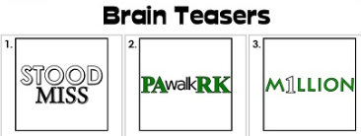
E
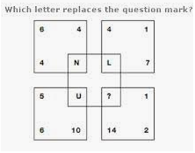
Y
E
O
P
E
N OR
E
R:

Summarizer: Describe how you believe your G4C scratch video game will look.

Proficient/Distinguished: Have you considered people who are visually impaired?
Have you considered other handicaps? How?
Take up the papers: person with the youngest grandma

Jan. 31, 2020 – Friday!
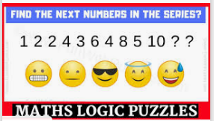
E.Q. How can G4C impact society? Is this a waste of time…or a good use of time? Why?
Eyeopener: 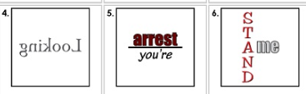

Summarizer: Sometime during this class period, you will send me a screen capture of the location you are working on in G4C. In one to two sentences write ‘what’ you are learning right now!

Proficient/Distinguished: What could you do to improve your progress in G4C?
How soon will you be ready to share you video games with others in the class before the due date of 3/31!
Take up the papers: person with the oldest granddad

Feb. 3, 2020 – Monday!
E.Q. How can G4C impact society? Is this a waste of time…or a good use of time? Why?
Eyeopener: 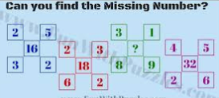
Why is today called Super Monday? Should Super Monday be a work/school holiday & why?

Summarizer: Share at your table your progress…who is furthest on their game?
Proficient/Distinguished: How can you improve your progress on your game? How could you help someone improve their progress on their game?
Take up the papers: Who was born furthest from MZ?

Feb. 4, 2020 – Tuesday!
E.Q. How can G4C impact society? Is this a waste of time…or a good use of time? Why?

Eyeopener: 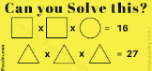

Summarizer: Make a puzzle (like the beginning of class) Show your solution underneath (so we can use them later).

Proficient/Distinguished: Why to puzzles/games exist? How likely are you to play a puzzle/game? Why?
Take up the papers: Who has on the darkest top/shirt.

Feb. 5, 2020 – Wednesday!
E.Q. How can G4C impact society? Is this a waste of time…or a good use of time? Why?
Eyeopener: 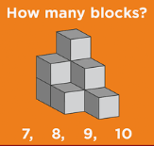

Summarizer: Should video games be designed alone or in a group? Why?
Proficient/Distinguished: What is synergy? How can Synergy be applied at your table?
Take up the papers: who has the darkest jeans/pants

Feb. 6, 2020 – Thursday!
E.Q. How can G4C impact society? Is this a waste of time…or a good use of time? Why?
Eyeopener:
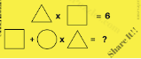
& look back to Tuesday’s eyeopener for help!
FROM TUESDAY!!!

Summarizer: How should video games be tested?
Proficient/Distinguished: What is the value in allowing a person to test your video game? What is the value in allowing many people to test your video game?
Take up the papers: who has the longest hair

Feb. 7, 2020 – Fri-yay!
E.Q. How can G4C impact society? Is this a waste of time…or a good use of time? Why?
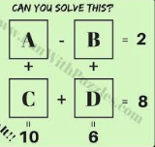
Eyeopener:

Take about 5 minutes to figure this out….talk to people at your table.

Summarizer: How many weeks until winter break? How many weeks until G4C is due?

Proficient/Distinguished: How many days do we go to school a year? What is the advantage or disadvantage to year-round schooling?
Take up the papers: who has the shortest hair

Feb. 10, 2020 – Monday!
E.Q. How can G4C impact society? Is this a waste of time…or a good use of time? Why?
Eyeopener: 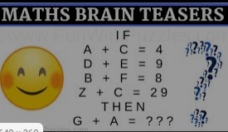
Summarizer: Discuss your topic of choice for G4C from the 3 available. Why did you pick this one over the others.
Proficient/Distinguished: If you could eliminate a G4C topic what would it be and why?
Is three enough topics, why or why not?
Take up the papers: who has the oldest sibling

Feb. 11, 2020 – Tuesday!
E.Q. How can G4C impact society? Is this a waste of time…or a good use of time? Why?
Eyeopener:
Why? Because all “rings” add up to 30!

Summarizer: Discuss with your table what you goal is for your G4C game this week. Be ready to share.
Proficient/Distinguished: Why are goals important?
If you wanted to increase your goal, just alittle, what would you need to do?
Take up the papers: who has the oldest father

Feb. 12, 2020 – Wednesday!
E.Q. How can G4C impact society? Is this a waste of time…or a good use of time? Why?
Eyeopener: 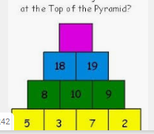
Summarizer: Where is your emoji? Do you need to move your emoji? Please do that.
Proficient/Distinguished: Why were emojis developed?
Please create an emoji for a ‘new feeling.’ (we will try to guess what feeling these emojis are expressing soon!)
Take up the papers: who has the oldest mother

Feb. 13, 2020 – Thursday!

E.Q. How can G4C impact society? Is this a waste of time…or a good use of time? Why?
Eyeopener: 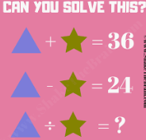
Summarizer: Is G4C a productive use of time? Why?
Proficient/Distinguished: Why do students play video games?
Should there be laws against/for limits on screen time for students.? Please explain.
Take up the papers: who has the youngest sibling

Feb. 14, 2020 – Friday!
E.Q. How can G4C impact society? Is this a waste of time…or a good use of time? Why?
Eyeopener: 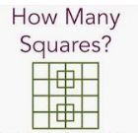

Summarizer: Who are the sponsors of this year’s topics?
Who would be the sponsor of your newly created topics?
Proficient/Distinguished:
Take up the papers: who has the youngest mother

Feb. 24, 2020 – Monday!
E.Q. How can G4C impact society? Is this a waste of time…or a good use of time? Why?
Eyeopener: You should REEEAAALLLY be getting close to having a G4C video game to submit! Look in Mouse/Scratch and determine where you are at with your game. Use your coding vocabulary to answer
1) what is done
2) what is left
3) what is the due date of the G4C?

Summarizer: How valuable is peer feedback in your game creation…why or why not?
Proficient/Distinguished: Have you set goals for your game?
What goals have you set for your other classes?
Take up the papers: the person who traveled furthest from home this winter break.

Feb. 25, 2020 – Tuesday!
E.Q. How can G4C impact society? Is this a waste of time…or a good use of time? Why?
Eyeopener: Try Lava Run 2 https://scratch.mit.edu/projects/362515988/
List 3 or more good things.
List 3 or more things the designer should change.
List 3 things you could change to make one of the G4C topics!

Summarizer: What is better for you a re-mix game or a game from Scratch & why?
Proficient/Distinguished: What should be the first steps for game creation?
What should be the final steps of game creation?
Take up the papers: The person who stayed closest to home over winter break.

Feb. 26, 2020 – Wednesday!
E.Q. How can G4C impact society? Is this a waste of time…or a good use of time? Why?
Eyeopener: Try Icon Creater
https://scratch.mit.edu/projects/362515988/

What is good about this game? What is bad about this game? Please read thoroughly the “Notes and Credits” section. What do you need to improve on your “Notes and Credits” section?
Summarizer: Was Icon Creator an inclusive game? Why or why not? What changes might you make?
Proficient/Distinguished: Why are instructions provided?
Do you read instructions before you start?
Take up the papers: Who has the most household members?

Feb. 27, 2020 – Thursday!
E.Q. How can G4C impact society? Is this a waste of time…or a good use of time? Why?
Eyeopener: Try Roller Coaster Builder
https://scratch.mit.edu/projects/364502191/

How could you make this into a game for
a) a clean & friendly earth
b) the human-animal bond
c) inclusive play
discuss your ideas with your table
Summarizer: What changes do you need to make in order to get your game ready for peer feedback, so you can submit?
Proficient/Distinguished: Do you know of someone with a disability?
Why do we want to design games for inclusive play?
Take up the papers: Who has the smallest number of household members?

Feb. 28, 2020 – Friday!
E.Q. How can G4C impact society? Is this a waste of time…or a good use of time? Why?
Eyeopener: Try Super Ultimate Coin Run
https://scratch.mit.edu/projects/364290631/

if you re-mixed this game, what would be the easiest topic to re-mix to a clean & friendly earth, the human-animal bond, or inclusive play. What changes would you make? Be ready to share.

Summarizer: Think about the Super Ultimate Coin Run…re-mix to a different topic (one you didn’t choose at the beginning of class). What would you need to do?
Proficient/Distinguished: What games does the ‘Coin Run’ remind you of?
What is easy about the game? What is difficult about the game?
Take up the papers:

Mar. 2, 2020 – Monday!

E.Q. How can G4C impact society? Is this a waste of time…or a good use of time? Why?
Eyeopener: There are 22 school days left until your G4C game needs to be submitted! From the games we have played in class describe what you like best about a G4C game and least about a G4C game.
Summarizer: What makes a video game good?
Proficient/Distinguished: Share with your table your different ideas for making a video game good.
Whose idea is best and why?
Take up the papers: the person at your table who is furthest along in their G4C design.

Mar. 3, 2020 – Tuesday!

E.Q. How can G4C impact society? Is this a waste of time…or a good use of time? Why?
Eyeopener: Try iPhone Simulator v1.2
https://scratch.mit.edu/projects/361417135/
Write a minimum of 4 sentence on what you could do to change this to the topic of a “clean & friendly earth.”
Summarizer: Why is a clean and friendly earth a good choice for a G4c game design?
Proficient/Distinguished: What are some things you see that need to be cleaned up around the earth?
What is an idea to clean this item up?
Take up the papers: The youngest person at your table.

Mar. 4, 2020 – Wednesday!
E.Q. How can G4C impact society? Is this a waste of time…or a good use of time? Why?
Eyeopener: If you were trying to describe block programming to a younger student, what would be some tips on getting them started in Scratch.
Summarizer: What is the youngest age block programming should be introduced at school?
Proficient/Distinguished: What is a ‘challenging’ block of code to use?
Why do you believe it is challenging?
Take up the papers: The oldest person at your table.

Mar. 5, 2020 – Thursday!
E.Q. How can G4C impact society? Is this a waste of time…or a good use of time? Why?

Eyeopener: Try Upside-poʍu | A Mobile Platformer
https://scratch.mit.edu/projects/368592589/

Write a minimum of 3 sentences on what you could do to change this to the topic of the “human-animal bond benefit.”
Summarizer: Are there laws to protect animals? If so, what are they?
Proficient/Distinguished: Do all animals need to be protected?
Who should be in charge of protecting animals and enforcing these laws?
Take up the papers:

Mar. 6, 2020 – Friday!
E.Q. How can G4C impact society? Is this a waste of time…or a good use of time? Why?
Eyeopener: Try Hard Game - a labyrinth
https://scratch.mit.edu/projects/325948758/

Write a minimum of 4 sentences on what you could do to change this to the top of “inclusive play.”
Summarizer: Included vs excluded
How does the word ‘included’ make you feel?
How does the word ‘excluded’ make you feel?
Proficient/Distinguished: What are some places that ‘exclude’ people?
What are some places that ‘include’ people?
Take up the papers:

Mar. 9, 2020 – Monday!
E.Q. How can G4C impact society? Is this a waste of time…or a good use of time? Why?
Eyeopener:
Summarizer:
Proficient/Distinguished:
Take up the papers:

Mar. 10, 2020 – Tuesday!
E.Q. How can G4C impact society? Is this a waste of time…or a good use of time? Why?
Eyeopener:
Summarizer:
Proficient/Distinguished:
Take up the papers:

Mar. 11, 2020 – Wednesday!
E.Q. How can G4C impact society? Is this a waste of time…or a good use of time? Why?
Eyeopener:
Summarizer:
Proficient/Distinguished:
Take up the papers:

Mar. 12, 2020 – Thursday!
E.Q. How can G4C impact society? Is this a waste of time…or a good use of time? Why?
Eyeopener:
Summarizer:
Proficient/Distinguished:
Take up the papers:

Mar. 13, 2020 – Friday!
E.Q. How can G4C impact society? Is this a waste of time…or a good use of time? Why?
Eyeopener:
Summarizer:
Proficient/Distinguished:
Take up the papers: WORK DAY??

